CORPORATE BODY PRACTICE
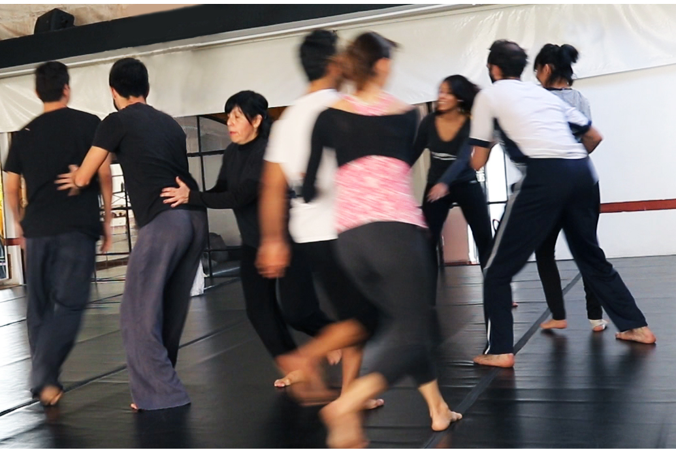
A fresh and innovative proposition to improve collaborative skills of workers in corporate organizations, introducing movement as a formative practice to develop ease and stability within a group of individuals.

Free workshops in Paris (France) and Antwerp (Belgium) in 2017
Information, dates and inscription below
CORPORATE BODY PRACTICE
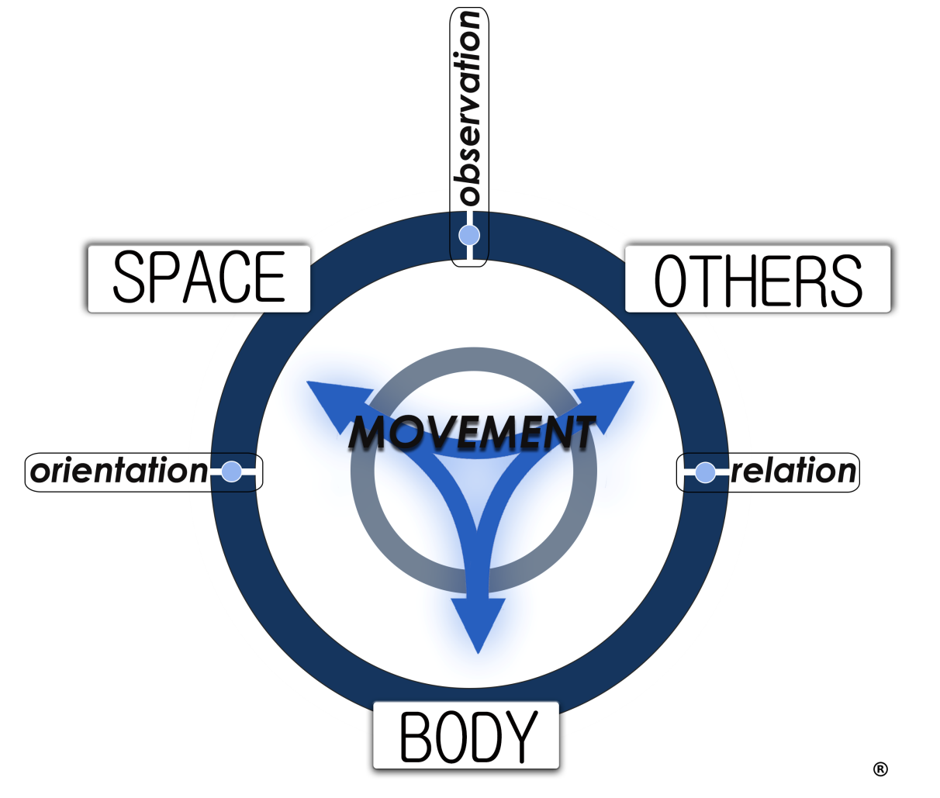

- Motricity
- Autonomy
- Coordination
- Awareness
- Mapping
- Problem solving
- Availability
- Communication
- Collective action

- Movement organizes our body in space and in relation to the others. And it organizes the body of the others in space. Three problems arise at the connective points between these core elements: how to orientate, observe and relate?
- Corporate Body Practice stimulates participants with challenges in orientation, observation and relation based on movement tasks. It enhances the set of skills that naturally root in our body: autonomy, awareness, communication, observation, pro-activity etc...
- Building upon these tools and our body intelligence, Corporate Body Practice aims at generating ease and stability for the daily working relationships in a corporate environment.
- A Corporate Body Practice session builds upon a series of tasks involving the body in relation to space and to a group of others. It gives place to practice, observe and discuss how to use proficiently our body in the complexity of our working contexts.

Video presentation: https://youtu.be/lhFlx5fMswg

More info on: Corporate Body Practice

Calendar 2017:
- Saturday 25th of March 2017: Antwerp (Belgium ) in English: from 12h to 14h
in Studio 501 (Top Studio - Above Grand Café)– DeSingel – Desguinlei 25, Antwerpen
- Saturday 22th of April 2017: Paris (France) in French: from 10h to 12h
in Studio D – Studio Harmonic – 5 Passage des Taillandiers, 75011 Paris
- Future dates to be communicated later

In 2017, all sessions will be for free, registration at corporatebodypractice@outlook.com

Training clothes are required, previous experience in movement/sport/dance isn’t.
Open to all ages and conditions.

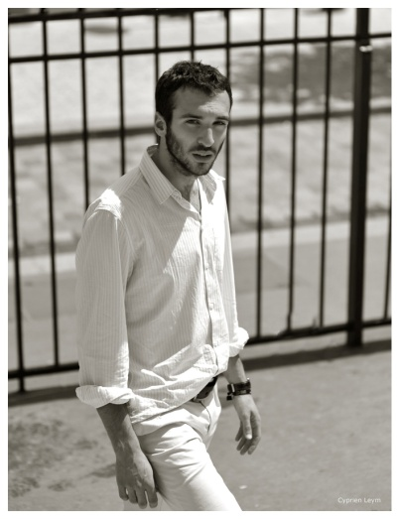
Laurent Delom is a dance maker and researcher who first worked as an engineer (graduated from Supélec - France in 2008) before turning to dance. He graduated in 2016 from the Royal Conservatoire of Antwerp (Belgium) and is now living in Paris. He operates in Belgium, France and Mexico. Besides dance he pursues academic research in transmission of dance skills and in aesthetics.
corporatebodypractice@outlook.com
FR: + 33 (0) 6 73 14 43 74 // BE: + 32 (0) 4 876 34 889
www.laurentdelom.com
Corporate Body Practice is a research initiative launched in 2016 by Laurent Delom. It aims at transferring body-based skills acquired through movement practice to adults working in corporate or institutional organizations. It focuses on competences most needed for daily collaborative interactions and personal development.
The project is supported by:
